Console Paint Program

**Console Paint Program**

Create a console paint program using Object Orientated Principles of encapsulation, inheritance, and polymorphism:

You will utilize the following class hierarchy:

A screenshot of a cell phone

Description generated with very high confidence

Shape class:

abstract base class for the Rectangle, Circle and Line class.

IBrush property – contains the brush to use to draw the shape.

Draw method - abstract method and therefore must be defined by all base classes

SetColor method - virtual protected method used to set the console color before the shape draws

ResetColor method - virtual protected method used to reset the console color back to the default after the shape draws. The default console color is ConsoleColor.Gray.

Rectangle, Circle, and Line classes extend Shape provide the draw method and prompt the user for any necessary variables.

IBrush interface:

Color – the console color that should be used for the drawing

Stroke – is the Unicode character that will be used to print the shape e.g. _ or Ω, or Δ. A good resource to find Unicode characters and there numbers is here: <https://www.rapidtables.com/code/text/unicode-characters.html>

Resources

* for ascii shapes is here: shapes from here: <http://ascii.co.uk/art>
* Unicode <https://www.rapidtables.com/code/text/unicode-characters.html>

Example run:

c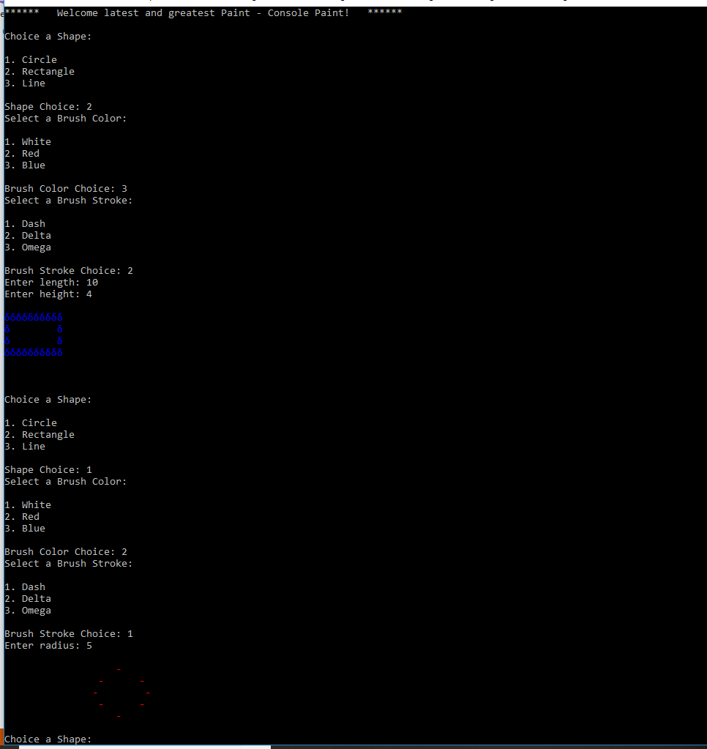

Your main program should prompt for a shape and a brush. With that information you can create the appropriate Shape and Brush objects. Then you can call Draw on your shape.

Notice that each shape prompts for different parameters since they need different variables to draw. In the example above the Rectangle shape prompts for length and height whereas the circle shape prompts for a radius.